**Getting Started with the FNNR-ABM Project**

Glossary

ABM – Agent-based Model

IDE – Integrated Development Environment

OS – Operating System

Table of Contents – to be added later

In order to access and download this project (for Python beginners):

1. Have Python 3+ installed on your computer.

To download the latest version of Python, visit <https://www.python.org/>. At time of writing, [Python 3.6.1](https://www.python.org/downloads/release/python-361/) is the latest version, though again, any version of Python 3.X.X should work. Python 2.X.X is more stable for use with older systems, but it differs in syntax from Python 3.X.X, so it is not compatible with code from the imported libraries we will use here (such as Mesa).

On the Python download page, scroll to the bottom and select the option that is best for you. For the most common configuration, refer to Figure 1.1; however, it may not apply to you. First, find out if you have a Mac, Linux or Windows OS, then figure out if your OS is 32-bit (x86) or 64-bit (x64). To find this out, view your computer properties (on Windows 10, search or find ‘This PC’ in File Explorer, right-click, and select ‘Properties’ from the menu; other versions of Windows might need you to right-click ‘My Computer’). Most standard newer computers will have the 64-bit version of Windows.

Once you download and run the installer (or configure the zip file/tarball; the installer is recommended), follow the installation steps to install Python 3.X.X onto your computer. If you are not sure what options to pick, do not change the default options. Keep note of where Python is installed on your computer. If it is convenient and fast to do so, restart your computer afterwards.

Figure 1.1 – The most common option. This option may not be right for you if you are not using a 64-bit version of Windows.

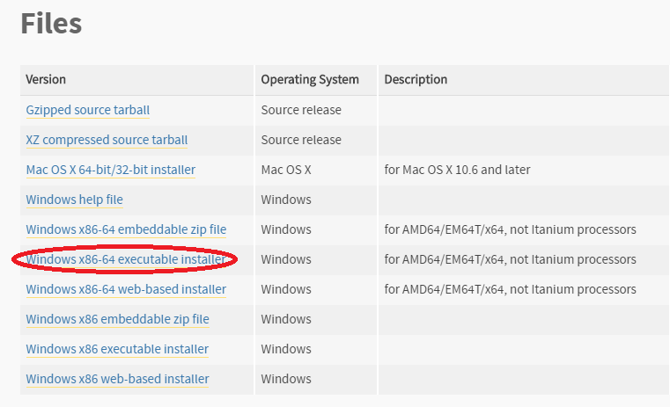

2. (optional) Download a Python IDE.

There are many different software programs that will run your Python code. IDEs are optional to download because Python comes with a default one named IDLE (and for shorter python functions, one can even run code straight from the command line). However, downloading a more sophisticated IDE will handle different versions of Python and different libraries more seamlessly, as well as provide debugging/testing tools and more detailed error messages. They may also provide other tools such as a built-in file system to manage multiple Python modules (files) more easily, the ability to open non-Python files, and more.

Once you have found an IDE (google to find different ones available; the one used in this tutorial is PyCharm), follow installation instructions, unzipping/extracting any files with 7zip (a free program) or Winzip as needed.

3. Download the Python libraries needed for the project (Mesa, openpyxl).

Python has many built-in frameworks and libraries (collections of pre-written functions and modules) that save users time and effort, as well as many more libraries available on the web to download; most common projects will use at least one external library (as opposed to being coded entirely from scratch). The two libraries we must download for the project are:  
  
Mesa – a Python 3+ framework for working with agent-based models

If you install Mesa through pip (covered later here), it will come installed along with the other libraries it depends on, such as Tornado (web framework), Pandas (data structure library), Numpy (for a variety of numerical expressions or generations), Six (for wrapping over differences between Python 2 and 3), Tqdm (progress meter), Matplotlib (for plotting, and more. The user will likely not directly access these libraries when working with Mesa, but they should be aware of what the libraries do.

Openpyxl – helps import data from cells in Microsoft Excel or Open/LibreOffice Calc files

The most common (and Pythonic) way to install external libraries is to open the Command Prompt on Windows (cmd.exe), or a similar terminal on whatever OS you’re using, and type in:

pip install mesa

and when that’s done,

pip install openpyxl

If you are using conda or miniconda (or another environment/package manager), replace ‘pip’ with ‘conda’ in the above commands.

**Troubleshooting**

There are a number of possible error messages you can get. The instructions below diagnose them based on Windows 10.

*If ‘pip’ is not recognized in the command window:*

1. Set the Environment Path.

a. This PC or My Computer > Right-Click > Properties

b. Click on ‘Advanced system settings’ on the left tab.

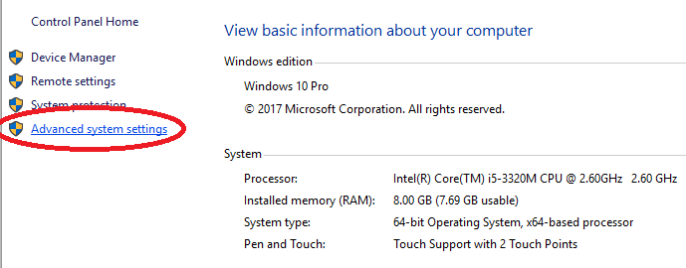

c. Select ‘Environment Variables...’.

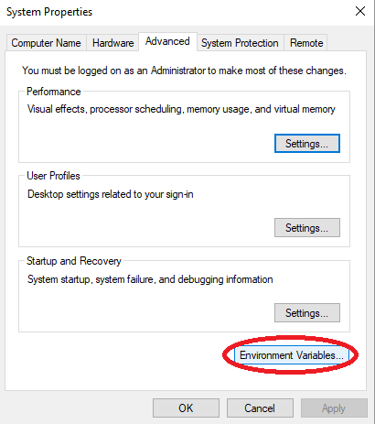d. Select ‘Path’ under ‘System Variables’ (near bottom of the window, not the first ‘Path’ near the top), then ‘Edit...’.

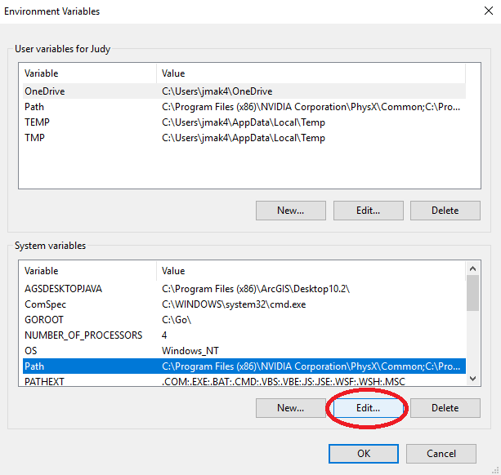e. Select ‘New’, then ‘Browse...’ to find where your Python installation is. Common filepaths to add here include (depending on where you’ve installed Python):

C:\Python27 ← likely

C:\Users\<YOUR USERNAME>

C:\Users\<YOUR USERNAME>\Downloads

C:\Users\<YOUR USERNAME>\AppData\Local\Programs\Python\Python36 ← most likely

Basically, add the directory that contains the same version of python.exe that you want to run, and maybe others, such as your Downloads folder, to be safe. Make sure that when adding new filepaths, you do not overwrite old ones in the current list.

*NOTE: If you have multiple versions of Python installed, make sure that the Python version you want is moved up above the other version(s). To do this, select the ‘Move Up’ button in the Path > Edit… window. Now you should be able to run pip in the command line to install the necessary libraries.

2. Change the CMD Directory.

For example, if you have Python installed under C:\Users\<YOUR USERNAME>\AppData\Local\Programs\Python\Python36, then in cmd.exe, you may want to type:

cd C:\Users\

in order for cmd.exe to look for pip in the right drive.

*If it installs successfully in the wrong directory, or if your IDE does not recognize the library after installation:*

3. If you are using Anaconda/Miniconda and the library has installed the library in the wrong environment (such as one for a version of Python 2.X.X), set up a new environment; otherwise, skip to Step 4.

To set up a new environment, type the following into the Command window:

conda create --name 3point6 python 3.6

Note: ‘3point6’ here can be any name you wish, and ‘3.6’ can be changed to another version of Python.

Then activate the env in the Command window:

activate 3point6 (or whatever you named it)

You should be able to use the pip command to install the needed libraries under this new environment now. After you do so in the command line, proceed to Step 4.

4. Change your IDE/project interpreter.

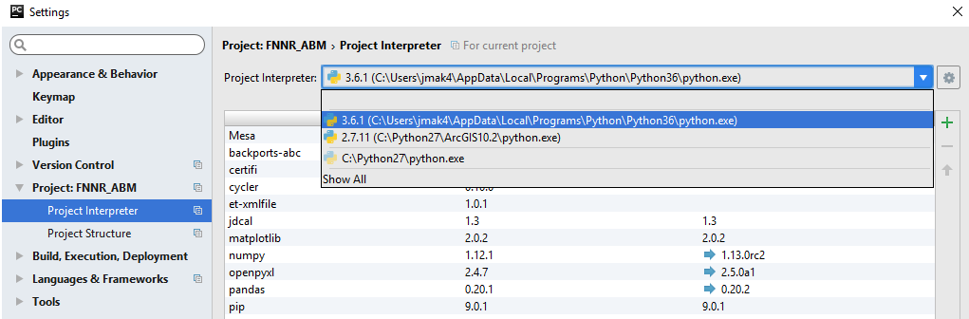

This varies per IDE, but in PyCharm, you will want to go to File > Settings to set the Project Interpreter. The Project Interpreter should either be wherever you have the desired version of Python installed, or in a Conda environment that has the desired version of Python installed (see Step 3). You will know you’ve selected the correct environment when:

- the Python version shown is 3.X.X, and

- the libraries shown in the table under the Interpreter selection dropdown box include pip, matplotlib, openpyxl, pandas, Mesa, and more (assuming that you have successfully used pip or conda in the command line to install the libraries at this point).

Finally, if your libraries appear to have successfully installed to the same directory that runs the desired version of Python as configured in your IDE, but you still get import errors, you may need to restart your computer.

4. Download the FNNR-ABM project files from Github.

Github is a file hosting, sharing, and version-control website and tool, particularly for code files of various computer languages. It functions similarly to Google Drive, but for code. For the purposes of this project, it is useful for sharing and storing different versions of .py files in an easily-readable format for others to download. While Github is a powerful suite that comes with its own commands, named Git, we will only cover how to navigate the website’s basic functions here.

This project’s Github repository is located at <https://github.com/jrmak/FNNR-ABM>.

Once you navigate to the page, the files from the repository will be shown; the organization is similar to Window’s file system. To download the files, find the green button to the right that says “Clone or download.” This can only be done from the main repository page, and not individual files, though one may also copy and paste code directly from viewed raw files.

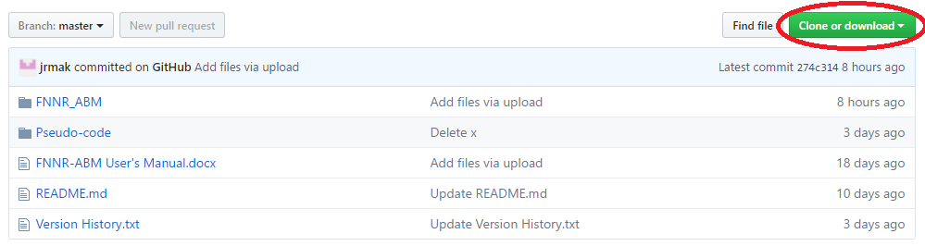

Make sure you are downloading the correct branch/version of the code. In this example, the master branch (see the leftmost grey button at the top of the image) is selected by default; it is usually the latest stable version of the project available. Once you click the green button, select the option on the right (download as .zip), unless you have Github for desktop installed and specifically want to edit the files from there (not be covered in this tutorial). The repository’s files will then be compiled into a .zip file; unzip it using WinZip or 7zip. The name of the folder should resemble ‘FNNR-ABM-master.’

Within this folder (also shown on the image above), the following files and folders exist:

FNNR_ABM – the main folder containing Python code for the project. Code is written by Judy.

In this folder: agents.py, model.py, server.py, excel_import.py, SimpleContinuousModule.py, simple_continuous_canvas.js, and the latest zipped version of the source data files.

*simple_continuous_canvas.js and SimpleContinuousModule.py (which uses the Javascript file simple_continuous_canvas.js) are part of the Mesa project and are not typically edited throughout the project.

These files are explained in readme.md on the main page of the repository, directly below the file listing.

Ask Dr. An or Judy for the password to the zipped data files, or ask Shuang for the unzipped version (which should be identical to the latest uploaded version on Github).

Pseudo-code – a folder containing various versions, arranged by month/day in 2017, of pseudocode that the main code is based off of. Pseudocode is written by Shuang.

FNNR-ABM User’s Manual.docx – this Word document.

README.md – contains the project description. Initializes with each Github repository.

Version History.txt – contains dated project updates and version descriptions. Also details Judy’s reported working hours, and a to-do list for coding.

Once these files are downloaded to your computer (you probably only need the code files within FNNR_ABM), move them to the appropriate location on your hard drive. If you are running a very basic setup with IDLE (the default Python IDE) it is possible to keep these files in your Downloads folder (in Windows), but the steps below are recommended.

Using PyCharm, create a new PyCharm project by File > New Project… in the upper left corner. Name the project however you want (I used ‘FNNR_ABM’) and place the project however you want (I prefer to keep the default under PycharmProjects, then once the project has been created, create the Python package using File > New… as shown in the figure below. (Select ‘Python Package’ from the drop-down list.) Name the Python Package FNNR_ABM, even if you’ve already named your project that.

(Note that in general, if you’d like to start a new .py file to code and save, select ‘Python File’ and not the generic ‘File’ type at the top of the menu.)

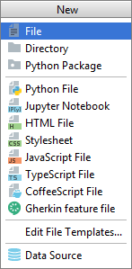

From the FNNR-ABM file you have on your computer, copy and paste your code (.py) files into PyCharm under your Python Package folder directory. Also paste the latest copy of the unzipped .xlsx Excel data file. The result on the left-hand window should look similar to this:

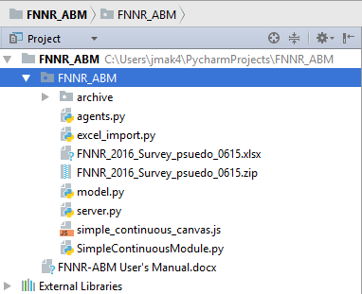

Note that if this window is not visible, you may need to toggle it to show within PyCharm. One way is to double-click the Python package’s tab:

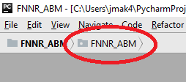

The code should now be visible whenever a module is opened from the left-hand side directory. To run the code, open server.py (it must be this module specifically) and press Shift + F10 or run it manually under the Run… option at the top toolbar. Afterwards, server (or server (1) here) should be the default module set to run next to the green buttons on the top right corner, as pictured below; you can also click the green triangle to run.

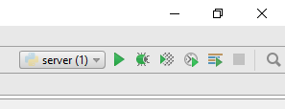

(Note: Demo to be shown once simulation is working again)

5. Understand the project goals, Excel data file, and pseudo-code.

The goals of the FNNR project are as follows:

- Simulate GTGP conversion of land parcels;

- Simulate how changes in PES policies will affect households; and

- Simulate in-migration and out-migration of FNNR inhabitants,

as well as visualize the above components through step-by-step interactive models, graphs, and text/tables.

The Excel data file is mainly important for the variables it contains for each household that can be used in the model. Important variables found in the data file (named in the format “FNNR_2016_Survey_psuedo_XXXX.xlsx”, with XXXX representing a month and day) include:

Global atttributes – year (represented by each ‘step’ in the model)

Household attributes – household id (separate from household row of Excel file), household position (coordinates), NCFP, charcoal income

Land parcel – land parcel position (coordinates), GTGP status, land area,

Individual attributes – individual id, name (represented by letters a-i), gender, age, education, marital status, work (labor) status, migration status (and if out-migrant, years spent out), birth interval (time since last given birth, if applicable)

6. Understand the Python code and imported libraries.

In this section is a detailed description of each module, its functions, and how the Mesa framework supports the code.

Mesa contains the following tools (as well as more not covered at this time):

- Defined Agent and Model superclasses that allow an ABM-style relationship between the two, as illustrated by time-steps

- Visualization and data-graphing components